IR NOTES
Unit 1: Foundations of Information Retrieval

Chapter 1: Introduction to Information Retrieval (IR) systems
1.1 Introduction to Information Retrieval (IR) Systems
Definition:
According to Gerard Salton (1968), a pioneer of the field,
“Information Retrieval (IR) is a field concerned with the structure, analysis, organization, storage, searching, and retrieval of information.”
In simple terms, Information Retrieval (IR) refers to the process of obtaining useful and relevant information from a large collection of unstructured data such as text, web pages, emails, and documents, based on a user’s query.
It focuses on finding information about a topic, not just matching exact data values as in databases.
For example, if a user searches “Causes of climate change”, the IR system should display documents, web pages, or articles related to that topic — not just one specific record.

Explanation:
Information Retrieval systems are designed to assist users in finding the most relevant information from massive document collections.
Unlike traditional databases (which store structured data in fields like name, ID, or balance), IR systems deal with unstructured or semi-structured data, where most content is in the form of natural language text.
For example:
- A bank database stores account numbers and balances in structured fields.
- But a news article about a “bank merger” contains text, headings, author names, and dates — all in different formats.
Because textual data has no fixed structure, IR systems use special algorithms to analyze, index, and rank documents according to relevance.

Goals of Information Retrieval:
- To provide relevant information to users:
The main goal of an IR system is to help users find the most relevant documents that satisfy their information needs.
- To organize and manage large information collections:
With the growth of the web and digital libraries, millions of documents are produced daily. IR systems organize them efficiently for quick searching.
- To support effective searching and ranking:
IR systems use techniques such as indexing, ranking, and term weighting (e.g., TF-IDF) to retrieve the most meaningful results quickly.
- To handle unstructured and semi-structured data:
IR systems are capable of processing data in multiple forms — text, images, audio, and video — by using metadata or content analysis.
- To ensure fast retrieval:
Since users expect instant results (like in Google), IR systems are optimized for high speed using indexing and caching techniques.
- To improve user satisfaction:
Modern IR systems learn from user behavior, feedback, and click patterns to deliver more accurate results over time.

Applications of IR:
- Web Search Engines:
The most common example — Google, Bing, and Yahoo — which help users find web pages related to their queries.
- Digital Libraries:
Used to search research papers, e-books, and articles (e.g., IEEE Xplore, ResearchGate).
- Enterprise and Desktop Search:
Helps organizations or individuals find files, reports, and emails from large internal data collections.
- E-commerce Search:
Websites like Amazon use IR techniques to display relevant products for user searches.
- Question Answering and Chatbots:
Systems like Siri, Alexa, and ChatGPT use IR combined with Natural Language Processing to answer user queries.
1.2 Components of an Information Retrieval (IR) System
An Information Retrieval (IR) system is a software system designed to help users find documents or information resources relevant to their needs — among large collections of unstructured or semi-structured content such as text, images or multimedia. The system’s architecture is built around several key components which collaborate to convert a user’s query into a ranked set of results.
Definition & Context
Before the search begins, the user has an information need— a mental desire to obtain information about a topic. This need is often expressed by the user in the form of a query (typically one to three terms in a Web scenario). For example, a user may type “machine learning applications” in a search box to satisfy an information need. The IR system then processes the query, matches it against an indexed document collection, computes relevance scores, and returns ranked results. Studocu+2St. Anne's College+2
Major Components
Here is a description of the main parts of a typical IR system:
- User / Query Interface
The front-end through which the user expresses their information need as a query. The interface may allow simple keyword input, phrase queries, wildcard or Boolean operators (e.g., inform* to match “inform”, “information”, etc.). It may also provide filters or field constraints (such as author, date, title). The query interface mediates between the user and the IR system to convert the natural-language need into a structured query. Studocu+1
- Query Processor
This component takes the user’s input and performs parsing, normalization (such as lower-casing, removing punctuation), tokenization (breaking input into terms), stop-word removal, stemming or lemmatization, synonym expansion or wild-card translation. The processed query is then prepared for matching against the index.
- Document Collection / Storage
The repository of all the documents or data items the system can search. These documents may contain text, metadata (title, author, date), and may also include images or multimedia content. Unlike structured database records, these documents tend to have unstructured bodies of text, making retrieval more complex. jeppiaarcollege.org
- Indexer / Inverted Index Construction
Key to efficient search is the index. The indexer processes each document in the collection and builds an inverted index data structure, which maps terms to the set (or list) of documents (and possibly positions) in which they appear. The index may store additional collection statistics (such as document length, term frequencies, document frequencies) to support ranking. Since the inverted list size is typically on the same scale as the document collection, indexing and update operations must be efficient. St. Anne's College+1
- Retrieval / Matching & Ranking Engine
Once the query is processed, the retrieval engine uses the index and statistics to compute a relevance score (often termed Retrieval Status Value — RSV) for each document relative to the query. The engine applies a retrieval model (Boolean, vector space, probabilistic, etc.), ranks the documents accordingly, and may apply additional processing (such as deduplication, host clustering). Documents are then sorted in order of decreasing relevance. Studocu
- Results Presenter / User Interface Feedback
The ranked list of documents is presented to the user along with snippets, document metadata (title, URL, summary), and optional tools for refocusing or filtering results. The presenter may also support user interactions like query refinement, relevance feedback, or suggestions.
- Evaluation & Feedback Loop
To ensure the IR system meets user needs effectively, evaluation metrics (precision, recall, F-measure) and test collections are used. User behaviour (e.g., click-through logs) may feed back to refine the system (e.g., improve ranking algorithms, query suggestions). The feedback loop allows the system to evolve based on user behaviour and measurement of performance. Studocu
Workflow Summary
- The user has an information need → expresses it via the query interface.
- The query processor transforms the query into a normalized form.
- The indexer, already built, helps rapidly locate candidate documents by matching query terms.
- The retrieval engine computes relevance scores, ranks documents, and generates a results list.
- The results presenter shows the ranked list to the user.
- User interactions and system performance feed into an evaluation and feedback loop to improve future retrieval.
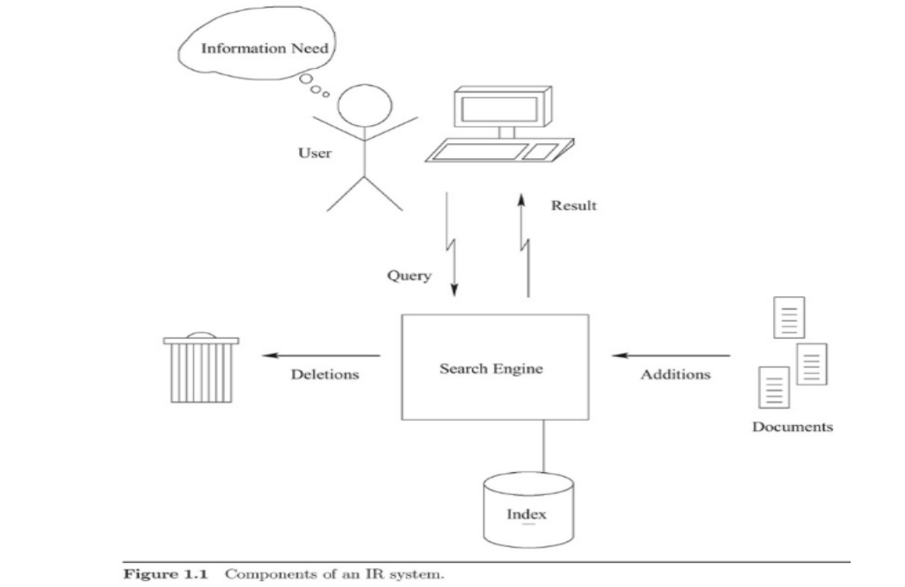

Goals of Information Retrieval (IR)
Introduction
The primary goal of Information Retrieval (IR) is to help users find the most relevant information from large collections of unstructured data, such as documents, web pages, or multimedia files. Unlike traditional databases that deal with structured data (like tables), IR focuses on retrieving information based on the content and meaning of text.

Main Goals of Information Retrieval
1. Relevance
- The most important goal of IR is to retrieve documents that are relevant to the user’s query.
- A relevant document is one that satisfies the user’s information need.
- IR systems use different models (like Boolean, Vector Space, or Probabilistic) to rank documents by their relevance.
Example:
If a user searches for “renewable energy sources,” the system should show results like “solar energy,” “wind energy,” etc., not unrelated topics like “fossil fuels.”

2. Precision and Recall
- Precision: The fraction of retrieved documents that are relevant.
$$\text{Precision}=\frac{\text{Relevant Documents Retrieved}}{\text{Total Documents Retrieved}}$$
- Recall: The fraction of relevant documents that are successfully retrieved.
$$\text{Recall}=\frac{\text{Relevant Documents Retrieved}}{\text{Total Relevant Documents}}$$
- The goal is to maximize both precision and recall, though often there is a trade-off between them.

3. Efficiency
- An IR system should retrieve results quickly, even from massive datasets.
- This requires efficient indexing, searching, and ranking algorithms.
- The efficiency of search affects user satisfaction and overall system performance.

4. Scalability
- With the explosion of digital content (e.g., the web), an IR system must handle billions of documents.
- The goal is to scale the system so that performance remains stable as data grows.

5. User Satisfaction
- The system should provide an easy-to-use interface, fast results, and ranked answers that match user intent.
- It may also provide query suggestions, spelling corrections, or relevance feedback to improve user experience.

6. Adaptability and Learning
- Modern IR systems aim to learn from user behavior (e.g., clicks, queries, preferences).
- This helps improve personalized search results, which is a growing goal of advanced IR systems.
Challenges and Applications of Information Retrieval
Introduction
Information Retrieval (IR) systems are designed to help users locate relevant information from large collections of unstructured data such as web pages, articles, and documents.
However, due to the vast amount of data, variety of formats, and diverse user needs, IR systems face many challenges.
At the same time, IR techniques are applied in numerous real-life domains like web search, digital libraries, and recommender systems.

Challenges of Information Retrieval
1. Relevance and Ranking
- Determining which documents are most relevant to a user’s query is one of the biggest challenges.
- Users often use short or vague queries, making it difficult to understand intent.
- The IR system must rank results properly so that the most relevant appear first.
Example:
For the query “apple,” the system must identify whether the user means the fruit or the tech company.

2. Handling Unstructured Data
- Most information on the internet is unstructured text (no fixed format).
- Unlike databases, IR systems must analyze text meaning using linguistic and statistical methods.
- Extracting useful information from documents, images, and multimedia adds extra complexity.

3. Query Formulation and Expansion
- Users may not know the correct keywords.
- The system must support query expansion, auto-completion, and spelling correction to help users express their needs.

4. Multilingual and Cross-Lingual Retrieval
- The web contains documents in multiple languages.
- Retrieving information across different languages and translating queries accurately is a major challenge.

5. Scalability and Efficiency
- The number of web pages and digital documents is enormous.
- The IR system must store, index, and search efficiently even when handling billions of documents.

6. Evaluation of IR Systems
- Measuring performance (using precision, recall, and F-measure) is not always easy because “relevance” can be subjective.
- Different users may consider different documents as relevant.

7. Spam and Low-Quality Content
- Web IR systems must handle spam pages, duplicate content, and SEO manipulations.
- Ensuring trustworthy results is a continuous challenge.

Applications of Information Retrieval
1. Web Search Engines
- The most common application of IR.
- Search engines like Google, Bing, and Yahoo use advanced IR algorithms to crawl, index, and rank web pages.
- Includes techniques like PageRank and learning to rank.

2. Digital Libraries
- IR systems are used to organize and search academic papers, e-books, and archives.
- Helps researchers quickly find relevant publications.

3. E-commerce Search
- Online stores like Amazon and Flipkart use IR for product search and recommendation.
- Uses user profiles and feedback to improve results.

4. Recommender Systems
- IR concepts are used to suggest movies, songs, books, or products based on user interests and past behavior.

5. Question Answering and Chatbots
- Systems like ChatGPT, Google Assistant, and Siri use IR to understand queries and fetch accurate answers.

6. Social Media and Sentiment Analysis
- IR techniques help filter posts, identify trends, and recommend content on platforms like Twitter, Instagram, or YouTube.

